Bio 103 Lecture Outline: MUSCULAR SYSTEM 10/05
Course Coordinator: Martini, 1st ed.
L. Falkow Chapters 9,10

Introduction
A. Skeletal Muscle Tissue & the Muscular System
1. 3 types of muscle tissue
Skeletal
Cardiac
Smooth

2. Functions of Skeletal Muscle

a. Movement

b. Maintain posture

c. Support

d. Guard openings

e. Maintain body temperature (thermogenesis)

Anatomy of Skeletal Muscle

A. Connective tissue

1. Epimysium

2. Perimysium
Fascicle

3. Endomysium

Tendon

Aponeurosis

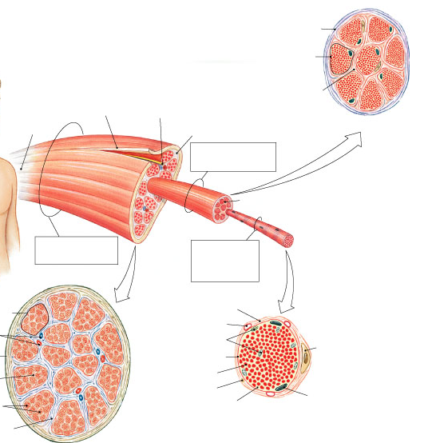

B. Organization of Skeletal Muscle Fibers

1. Muscle fiber = muscle cell
a. Multinucleated

b. Sarcolemma

c. Sarcoplasm

d. Transverse tubules (T-tubules)

e. Sarcoplasmic reticulum (SR)

2. Myofibrils
= bundles of thin and thick filaments

3. Myofilaments

a. Thin filaments
actin
tropomyosin
troponin

b. Thick filaments
tail
head
cross-bridges

4. Sarcomere = functional unit

A-band
I-band
H zone
Z-lines

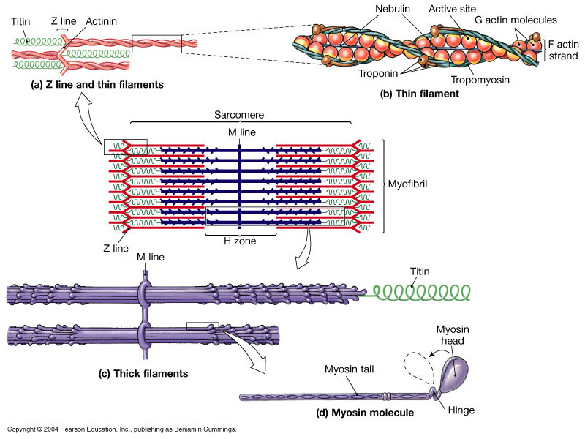

I-band A-band I-band

5. Sliding Filament Theory
* thin filaments slide past the thick filaments ==> muscle shortens
Supporting evidence:
- H zones and I bands narrow
- Z lines move closer together
- A band width does not change

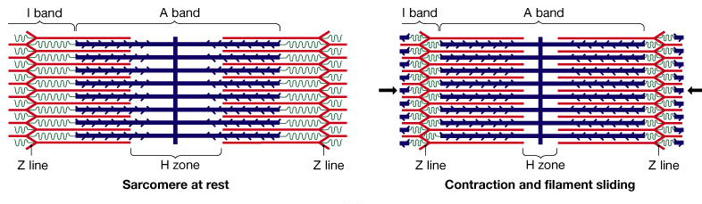

Contraction of Skeletal Muscle
A. Control of Skeletal Muscle Activity
- nervous system controls muscle contraction

1. Neuromuscular Junction (NMJ) or Myoneural Junction
a. Anatomy of the synapse
synaptic (axon) terminal
synaptic vesicles
acetylcholine (ACh) - neurotransmitter
synaptic cleft
motor end plate
ACh receptors
(acetyl)cholinesterase (AChE)

synaptic terminal

motor end plate

b. Skeletal muscle innervation:

1) AP travels along axon and arrives at synaptic terminal

2) ACh released

3) ACh binds at motor end plate

4) AP travels along sarcolemma
- at same time AChE recycles ACh

5) Return to initial state

B. Excitation - Contraction Coupling
- generation of AP along the muscle fiber => muscle contraction
1. Sequence of contraction events:
* Sarcolemma is excited by AP
* AP travels down t-tubules --> SR => release of Ca⁺²
* Ca⁺² move into sarcomere and bind to troponin

Contraction cycle begins:
a. active sites on actin are exposed
b. ==> cross-bridges form
c. myosin heads pivot (power stroke) => shortening of sarcomere
d. cross-bridge detachment
e. myosin reactivation

2. Sequence of relaxation events:
a. AChE breaks down (& recycles) ACh
b. Ca⁺² ---> SR (via AT)
c. [Ca⁺²] in sarcoplasm decreases => troponin reactivated
d. cross-bridge attachments are broken
=> actin and myosin return to resting positions
Muscle has returned to resting length.

C. Rigor Mortis
In living, resting muscle, normally ATP sits on head of myosin.
ATP ---> ADP + P + E in order for the power stroke to occur.
If no ATP available (as in death) => cross-bridges cannot break.

Tension Production
A. Tension produced by muscle fibers

1. All-or-none principle:

2. Frequency of Stimulation

a. Twitch: single stimulus =>
latent period

contraction phase

relaxation phase

b. Treppe

c. Wave Summation

d. Incomplete Tetanus

e. Complete Tetanus

Infectious disease: Tetanus (“lockjaw”)
- Clostridium tetani
- No relation to normal muscle contraction

B. Tension Produced by Skeletal Muscles

1. Motor Unit
= all muscle fibers associated with single motor neuron

precise movements

less precise control

2. Recruitment

3. Muscle tone

4. Isotonic contraction

5. Isometric contraction

Whole Muscle Anatomy

A. Parts of muscle

B. Muscle actions
1. Points of attachment
origin:

insertion:

Ex. Pectoralis major Biceps brachii

Origin:

Insertion:

Action:

2. Naming of muscle actions:

flexion
extension

adduction
abduction

C. Naming of Muscles:
1. action:

2. direction:

3. location:

4. divisions:

5. shape:

6. attachment:

7. Latin meanings:
platysma
buccinator
serratus
masseter
vastus
Energy for Muscle Activity
A. ATP and CP Reserves
ATP = adenosine triphosphate
CP = creatine phosphate (or phosphorylcreatine)
CPK (or CK) = creatine phosphokinase

ATP + creatine <-----------> ADP + CP

_{CPK}
ADP + CP -----------> ATP + creatine

B. ATP Generation
1. Aerobic metabolism
- takes place in mitochondria
- uses pyruvic acid ---> TCA (citric acid cycle) and
Electron Transport System ==> ATP

-G-G-G-G-G- <--------> glucose (6-carbon)
(Glycogen)
I GLYCOLYSIS
I 2 ATP(net) (anaerobic)
V
2 pyruvic acid (3-carbon)

O₂ Citric
Acid
Cycle + Electron Transport
System

==> CO₂ + H₂O + Energy
34 ATP(net)
-----------------
Total: 36 ATP/glucose molecule

2. Glycolysis (anaerobic respiration)
- takes place in cytoplasm
- breakdown of glucose to pyruvic acid

Glycogen <-------> Glucose I
I
V
Pyruvic Acid

Lactic Acid

Drawbacks to Anaerobic respiration:
a. accumulation of lactic acid:
- lowers pH
=> muscle soreness, fatigue

b. Glycolysis - inefficient way to produce ATP

C. Energy Use
1. Resting muscle
- low energy demands
- O₂ available
- buildup of CP and glycogen

2. Moderate activity
- energy demand increases
- incr. O₂ use and incr. ATP output
- no surplus of ATP

3. Peak activity levels
- max. mitochondrial ATP production (produces 1/3 of ATP)
- rate limited by O₂ available
- 2/3 ATP produced via

D. Muscle Fatigue
- use up ATP and CP
- lowered pH from lactic acid buildup
- damage to SR

E. Recovery Period

- time needed to rebuild energy reserves

- lactic acid removal & recycling

- Cori cycle

- oxygen debt

Muscle Performance

A. Distribution of muscle fibers
fast fibers - "white meat"
- large diameter
- lots of glycogen, not many mitochondria

slow fibers - "dark meat"
- half the diameter of fast fibers
- myoglobin
- lots of capillaries

intermediate fibers
- contain little myoglobin

B. Muscle hypertrophy and atrophy

Cardiac Muscle Tissue
A. Structural differences
cardiac muscle cells

B. Functional differences

Smooth Muscle Tissue
A. Structural differences

B. Functional differences

Clinical Disorders
Myasthenia gravis

Botulism

Polio

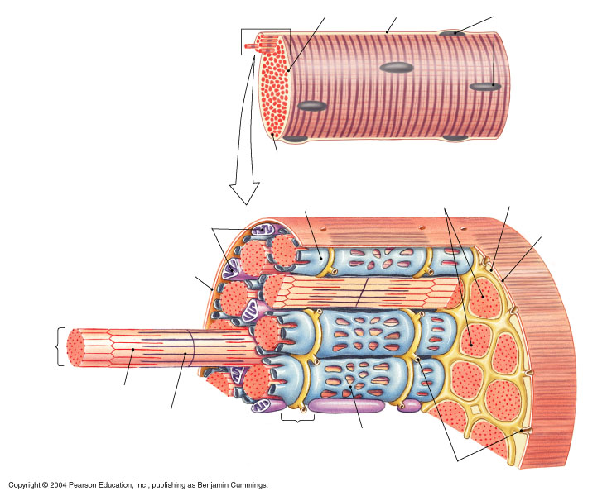

Exercise A: Muscle Function
Prentice-Hall Video Tutor

1. Bundles of muscle fibers, blood vessels, and nerves within a CT sheath are called _________.

2. The cell membrane of a muscle cell is the _________.

3. Each muscle fiber is composed of ________ which run the entire length of the muscle cell.

4. Bundles of thick and thin filaments are organized into repeating units called _________.

5. The repeating units (in #4) are joined at junctions called ______________.

6. Each thin filament is composed mostly of the protein ___.

7. Thin filaments have the appearance of ___________.

8. Thin filaments also contain 2 proteins _______ and _______ that are important
in control of muscle contraction.

9. Thick filaments are composed of the protein _________.

10. Each myosin is shaped like __________.

11. To make up a thick filament, the _____ of the myosin molecules are bundled
together and the _____________ project outward in a spiral.

12. The region where and axon communicates with a muscle cell is called ________.

13. The terminal process of the axon and the muscle fiber are separated by a small gap called _____________________.

14. A neuron can control a muscle fiber by releasing a chemical called
a ______________ into the gap between the neuron and the muscle fiber.

15. The ______________ stores the calcium ions.

16. When a muscle is at rest, _________ molecules hold _________ molecules against the actin strands.

17. The molecules (in #16) block the ______ binding sites on the thin filaments.

18. When ____ are released from the SR, they attach to ____________.

19. The ________ molecules rotate, moving the ________ molecules, and
exposing the _____________ binding sites.

20. A ____ forms when the head of a myosin molecule attaches to a binding site on the actin molecule.

21. When the muscle contract, the two ends of the sarcomere move ____________.

--------------------------------------------------------------------------------------------------------------------------------

Exercise B: Naming of Muscles:

1. Action:

2. Direction:

3. Location:

4. Divisions:

5. Shape:

6. Attachment:

7. Latin name:

Levator scapulae Triceps brachii
Gluteus maximus Quadriceps femoris
Tranversus abdominis Sternocleidomastoid

Internal Oblique Extensor carpi radialis
Rectus abdominis Pectoralis major
Flexor carpi ulnaris Deltoid
Adductor longus Trapezius
Brachialis External oblique
Biceps brachii Platysma
Buccinator Vastus medialis

Exercise C:

More muscle tissue review:

1. Muscle tissue is made up of specialized cells for the function of ___________.

2. The three types of muscle tissue: __________, _____________, _______________.

3. Skeletal muscles are called voluntary muscles because:
a. ATP activates skeletal muscle for contraction
b. Skeletal muscle contain myoneural jcn.
c. They contract when stim. by motor neurons of the CNS.
D. CT harnesses generated forces voluntarily

4. The smallest functional unit of the muscle fiber is ___________________.

5. Thin filaments consist of:

6. Thick filaments consist of :

7. All of the muscle fibers controlled by a single motor neuron
make up a ____________________.

8. Tension in a muscle fiber will vary depending on:
a. Structure of individual sarcomeres
b. Initial length of muscle fibers
c. The number of cross-bridges formed within a fiber

9. The reason there is less precise control over leg muscles compared to muscles of the eye is:

a. Single muscle fibers are controlled by many motor neurons.
b. Many muscle fibers are controlled by many motor neurons.
c. A single muscle fiber is controlled by a single motor neuron.
d. Many muscle fibers are controlled by a single motor neuron.

10. The sliding filament theory explains the physical change that takes place during contraction is:
a. Thick filaments slide toward center of sarcomere alongside the thin filaments
b. Thick and thin filaments slide toward the center of the sarcomere together
c. The thin filaments slide toward the center of the sarcomere alongside the thick filaments.

